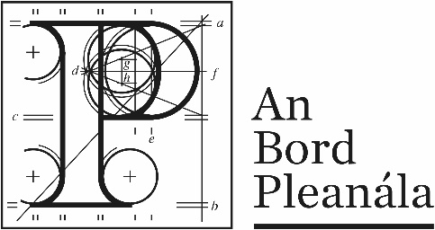
Documents received at Oral Hearing for
ABP-314232-22

Case Description | DART+ West Railway Order - Dublin City to Maynooth and M3 Parkway County Dublin, County Meath, County Kildare
Date | 5th October, 2023
Location | The Gresham Hotel, 23 O’Connell Street Upper, North City, Dublin, D01 C3W7

Documents received at Oral Hearing
No. | Submitted by | Presenter | Topic
 | Applicant | Barry Corrigan | Module C  1. MCA Option Costs  2. Road Design  Errata 2  3.Drawing -Visibility Splay
 | Gowan Group | Diarmuid Healy | Module C  A3 booklet
 | Gowan Group | Dermot Flanagan | Module C  Legal Document
 | OMS architects – Flynn & O’Flaherty Construction | John Smyth | Module C
 | Ashleigh Residents Association | Colm O’Toole | Module C  1.Submisson  4 photos attached
 | John Devitt | John Devitt | Module C  1. Email  2. Oral Statement  3.Observation  4. PowerPoint slides
 | Delwood Residents Association | Larry O’Sullivan | Module C  1.Submission  2.Submission part 2.2.5 onwards submitted 06/10/23
 | Applicant | Mr Bradley | Withdrawal John and Grainne Malone

